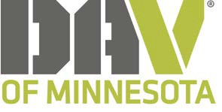

Award Nominations

Name of Nominee

Nominee Chapter

Chapter Position

Award Nominating For:

Commander of the year
Adjutant of the Year
Lyle C. Pearson Sr. Award (DAV’er award) Accomplishments this Year:

Lyle C Pearson Award is the highest honor given by the DAV of MN and is given to the member who goes above and beyond to help veterans and is very active in the community.

Please attach any supporting documents to support your nominations.

